5. System Response and LTI Properties
Experiment 5.1
Impulse Response of the System
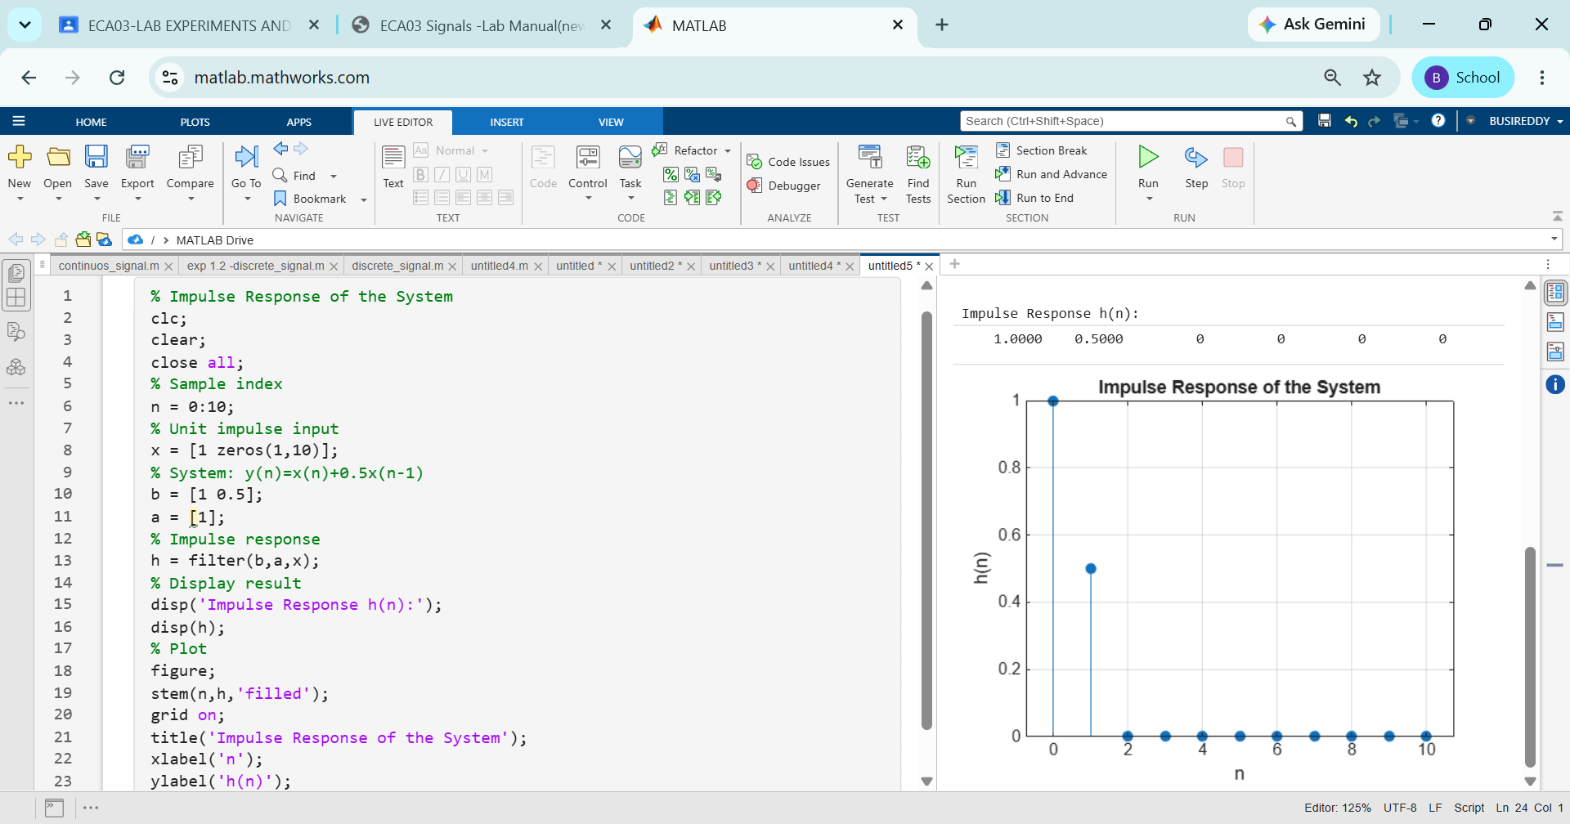
Experiment 5.2
Step Response of the System
